

Cover Sheet

Risk Mitigation Metric for Multi-Factor Authentication Systems
In Response to DARPA-PA-11-52 – Cyber Fast Track (CFT)

Lead Proposer Organization Name: | ProvenSecure Solutions, LLC
Type of Business: | Other Small Business
Other Team Members and Type: | Adom Giffin (Clarkson University)
Technical Point of Contact: | Name:  Address:  Telephone:  Email:  Fax: | Stephen Paul King  304 Beechwood Ave  Greenvile, SC 29607  864.567.3099  stephenpk@provensecure.com  N/A
Administrative Point of Contact: | Name:  Address:  Telephone:  Email:  Fax: | William Whitescarver  6037 Calumet Ct  Gainesville, VA 20155  703.508.0926  billw@provensecure.com  877.843.8372
Place(s) of Performance: | ProvenSecure Solutions, LLC is a virtual workplace. Resources are physically located in various places within the continental United States
Period(s) of Performance: | April, 2013 through August, 2013 (approx.)
Sub-Proposer Information: | None
Date of Proposal:  Proposal Validity Period (minimum 120 days): | 31-March-2013  Proposal valid for 120 days

Table of Contents
1. Cover Sheet 1
2. Table of Contents 2
3. Executive Summary 3
Synopsis 3
How It Is Done Today 4
What Makes This Project Novel/Revolutionary 4
What We Are Trying To Do 4
Who It Will Impact If Successful 4
What It Will Cost and How Long It Will Take 4
4. Technical Description 5
Technical Objectives 5
What is New and Why the Solution Will Succeed 5
Technical Challenges and Risk Mitigation 5
How Cyber Attack Surfaces are Impacted 5
Tactical or Strategic 6
How Traditional Adversary Approaches are Negated 6
How the Solution Incentivizes the Adversary 6
Analysis of the Asymmetry 6
How to Defeat the Effort 7
Use Case Showing the Benefit 7
5. Capability/Technology Information 7
6. Interactions with the Ad-Hoc Cyber Research Community 8
7. Metrics 8
8. Statement of Work 9
9. Schedule/Milestones/Deliverables 11
10. Cost 12
11. Appendix A 15
Team Member Identification 15
Government or FFRDC Team Member 15
Organizational Conflict of Interest Affirmations and Disclosure 15
Intellectual Property 15
Human Use 16

Executive Summary

Synopsis
The rapidly emerging use of multi-factor/multi-channel and bio-metric authentication systems presents a woefully under-appreciated and poorly addressed complexity in the service of providing user authentication. There does not currently exist an objective means to determine the measure of risk mitigation that a given MFA system can provide in a way that includes adaptive systems.
Typically, authentication systems (MFA or otherwise) ultimately provide one of two responses: either the user is successfully authenticated, or not. The truth of what is really going on is typically brushed under the carpet. Voice Print Identification and Facial Recognition are statistical in their very nature. They are not True/False systems, instead they are "Voice print authenticated to this degree..." and "This facial imagery matches to that degree". And to make matters worse, in the Multi-Factor scenarios, several such systems' answers must be combined to produce a single authentication result. Stated plainly, modern multi-factor authentication is not a situation where a user passes a “voice check”, passes a “face check”, and passes some other check. Each test involves a matter of degree, and it is the integration of statistical results from all tests that determines the result of the authentication.
All authentication systems will have flaws and work-a-rounds. Each factor has inherent risks that can allow for the system to be compromised by some means and this information is typically not delivered and dynamically analysed as part of the authentication results. For example, fingerprint data technically can be captured and replayed, rudimentary voice factor authentication may be susceptible to record and playback, and facial recognition systems might give a pass to a photograph of a face. MFA systems are touted as being more secure simply because of the combination of factors, and this seems to make sense, but objectively, a quantitative method of ensuring this is needed.
It is well known in literature that combining and requiring multiple (independent and/or partially dependent) methods of authentication increases security. As multi-factor authentication becomes the de facto standard, questions arise as to what first has gone in to assessing the exact risk of the component authentication factors and systems, and exactly how much authentication is appropriate for the given authentication situation. Which factors are susceptible to being fooled or somehow compromised? Can the identity of a person be completely simulated or effectively cloned? Will a “just in time” random selection of authentication factors be any better at defending against such an attack than a predetermined authentication regimen?

How It Is Done Today
There are currently two popular methodologies for assessing the statistical reliability of an authentication protocol: Bayesian and Maximum Entropy (MaxEnt). While they both have their merits, recent development of a third methodology, Maximum relative Entropy (MrE)⁽³⁾ includes not just MaxEnt but also Bayes rule as special case. MrE is capable of reproducing every aspect of orthodox Bayesian inference methods and thus opens the door to tackling problems that could not be addressed by either the MaxEnt or orthodox Bayesian methods individually.

What Makes This Project Novel/Revolutionary
This method of using the Maximum relative Entropy fuses the techniques of both Bayesian analysis and Maximum Entropy modeling that allows for fine to coarse-graining of probability distributions. By studying a wide enough sample of real world multi-factor authentication events we can develop very accurate priors for the Bayesian codes.

What We Are Trying To Do
We propose a test case to apply the abilities of the MrE method to the assessment of multi-factor authentication risk and operational performance. We propose the delivery of a detailed analysis of the relative performance of all three mentioned statistical methodologies. We will develop the MrE statistical algorithm into a risk assessment tool that can be implemented as an operational "intelligent" driver of qualified multi-feature authentication scores over a spectrum of risks. Finally, we will demonstrate the resulting Risk Mitigation Metric (RMM) tool that will provide continuous-scale quantitative results of representative authentication attempts.

Who It Will Impact If Successful
Such a tool, in a refined form, would be beneficial (if not critical) to any comprehensive authentication system where it is necessary to assess effectiveness (and therefore potential risk of breach) in any real-world environment.

What It Will Cost and How Long It Will Take
We anticipate the total effort to achieve these goals will require 4 months (78 working days) and require approximately $132,000 to complete.

Technical Description

Technical Objectives
Our research will define a method using MrE principles to generate practical dynamic metrics of risk mitigation for multiple authentication factors. Our application of this method will be demonstrated using an (RMM) risk mitigation metric API.

What is New and Why the Solution Will Succeed
MrE is a technique of including both general and specific information in a formal model which, we believe, has been proven to have a superior objective inference potential.
MrE has already been shown to provide superior distributions in the area of econometrics as explained by Adom Giffin:
“...the method of Maximum (relative) Entropy (MrE) which has the advantage of not only assigning probabilities but updating them when new information is given in the form of constraints on the family of allowed posteriors.”
This property of taking advantage of updates from new data combined from, for example, the ongoing sequence of active and passive authentication events, is considered to allow for exponential increase in the efficiency of MFA systems. It is proposed that this allows for a method of objectively measuring the distributions of the risk mitigation effects that a MFA system can deliver.

Technical Challenges and Risk Mitigation
Two of the potential challenges in securing MFA systems is the quantity of computational capacity required for implementation of authentication events and the lag/process delay that is acceptable by the users of the systems. The MrE methodology seems very promising in its ability to track, measure and model the causal factors that generate many of these challenges. We need more study of these possibilities to have a better understanding of the promise of the MrE methods.

How Cyber Attack Surfaces are Impacted
By generating accurate statistical models of the relations between attack surface area and multiple independent authentication factor protocols, we propose to study the prevalent statistical constraint relations that the MrE method allows for the goal of successful ASA minimization strategies.
This new strategy will, inevitably induce similar attack profiles, but these are thought to be mostly depend on computational resources quantification. In other words, the MrE method generates a capacity of guidance or control of the MFA system that can only be overcome by a “smarter” attack system by looking at how distributions are affected by the MFA configurations.

Tactical or Strategic
This research effort aims at a strategic advantage that moves completely away from the centralized, fixed and layered “Castle in a Moat” strategy of security to a paradigm where security is enforced by a combination of Prediction, Anticipation and Occultation strategies implemented using mutable multi-factor authentication methods.
It can be strongly argued that such strategies tend to have highly unstable Nash equilibria, as the requirement for successful attack is dependent on very accurate simulations of systems that are secured by the means that a MrE methodology can afford and is sensitive to specific event configuration. Basically, a successful attack will require the ability to match move by move the variation of the MFA system.

How Traditional Adversary Approaches are Negated
Once methods that actively adapt to the particular attack instance become wide spread, it is expected that security measures will turn to methodologies involving occultation. Simply put, we must then work out methods to effectively hide the targets from the potential adversary by optimizing the MFA methodology per authentication event.
It is impossible to attack an enemy that one cannot locate. By effectively hiding the attack surface of a system, if implemented properly, we expect that almost all traditional attack methodologies will fail. This forces strategies by adversaries from one of direct attack on an easily visible target to simulating the target to anticipate its behaviors in order to exploit them.

How the Solution Incentivizes the Adversary
Adversaries will be forced to combine their individual resources in order to collect the required computational requirements to successfully simulate and out-match what the methodology that is being proposed should allow. This action will tend to degrade the asymmetric advantages of small groups of adversaries and perhaps even highly motivated adversaries with extensive resources.

Analysis of the Asymmetry
The MrE method should allow a diverse strategy of multiple biometric factors to be used concurrently in a way that is similar to a very large encryption key that can be changed when needed. It is expected that this strategy will adaptively increase security requirements for very risky exchanges or decrease them in cases of a fast and low risk interaction. The speed can be shown to be a factor of the available resources to process the authentication.
For an attack to be successful, the adversary must be able to muster sufficient computational resources to simulate the biometric data to at least the resolution demanded by the MFA. This allows the ‘good guys’ to keep the securitization level one epsilon above the expected ability of the adversaries.
Asymmetry From Different Roles of View
Short-Term Strategies | Attacker: DoS attack to bring down the DNS of the node.
Short-Term Strategies | Defender: Detect incoming attack and deploy honeypot botnets.
Short-Term Strategies | Role Advantage:Whoever has the most computational resources
Medium-Term Strategies | Attacker: Deploy array of sniffers to map out he interaction profile of the securitized node and hope for a successful simulation of the node’s authentication key.
Medium-Term Strategies | Defender: Continuous polymorphing of MFA factors
Medium-Term Strategies | Role Advantage: Defender
Long-Term Strategies | Attacker: Map a sufficient portion of the WWW to map the temporal pattern of behavior of the securitized node and use targeted DoS attacks on packets between the nodes.
Long-Term Strategies | Defender: Change sufficiently often to prevent sufficient mapping.
Long-Term Strategies | Role Advantage: Whoever has the most computational resources.

How to Defeat the Effort
If it is possible to secretly access all of the nodes of a secure system or server and sniff their traffic for long enough, it might be possible to simulate the required authentication profile of the authorized users.
An effective strategy that may defeat methods and means that take advantage of the MrE guidance, are thought to involve means to simulate exactly the behavior of the secured system. Since it is well known that simulating large and complex systems is extremely hardware intensive, it is believed that successful predictive simulation attacks on MrE guided secured systems will require very expensive hardware, even to the level of actual instances of quantum computers for the limit case of arbitrarily many independent identification factors and computational resources.

Use Case Showing the Benefit
Anyone that wishes to control the access to data and exchanges, such as purchasing carts, would benefit from the ability to measure the risk mitigation factors that would be required to securitize the data and exchange to a given risk tolerance factor.
Consider a multi-factor biometric authentication system that could use a large variety of authentication feature protocols and could spend just enough computational resources to match its risk tolerance level. This would make securing a system a lot more efficient.

Capability/Technology Information
This is the first solicitation for funding to perform this work. RMM is being proposed for the very first time.

Interactions with the Ad-Hoc Cyber Research Community
ProvenSecure Solutions, LLC currently has interactions with the cyber security community via relationships with researchers at NJIT, Clarkson University, AT&T Labs and the AT&T Foundry. This project will make use of technologies available through these resources. It may also make use of commercially available authentication products as part of the demonstration systems being constructed.

Metrics
 | Quantitative Criteria | Qualitative Criteria
Milestone 1  Evaluation of available Statistical Methods | Completion of a White Paper comparing and contrasting Bayesian, MaxEnt and MrE methodologies. | Comparison describes requirements and assumptions of each method.  Comparison describes relative strengths and weaknesses of each method.
Milestone 2  Develop specs for MrE algorithm and RMM tool | Functional (use case) specifications for RMM tool.  Detailed design specifications documented for RMM tool. | Specifications are sufficient to permit the construction of a working prototype and the specification of an API to interface with the prototype RMM tool.
Milestone 3  Develop specifications for Bench MFA client | Identification of authentication parameters that will be subjected to effectiveness analysis.  Specifications documented for MFA prototype/demo application. | Authentication methods and environments chosen for inclusion represent typical “real-world” situations that could stress an authentication system.
Milestone 4  Build and test Bench MFA client and prototype RMM tool | Demonstration environment including the “bench” MFA client and the prototype RMM tool is constructed and deployed. | Preliminary “acceptance” testing of “bench” MFA client and components indicate all is working to specification.
Milestone 5  Demonstrate prototype RMM tool using Bench MFA client and prepare final report | “Bench” MFA and RMM prototypes are exercised.  A final report describing the test/demonstration results is prepared. | Completed ”bench” MFA and RMM prototypes are tested and working to specification.  Final Report includes statistical results from testing and a discussion as to how these statistics may be used to strengthen a real-world MFA system.

Statement of Work
STATEMENT OF WORK (SOW)
Overall Objective | Describe MrE methodology relative to existing statistical analyses methodologies, and demonstrate its potential effectiveness in a Multi-Factor Authentication implementation.
Primary Organization | ProvenSecure Solutions, LLC
Specific Project Plan
Task 1 | Prepare White Paper comparing and contrasting Bayesian, MaxEnt and MrE methodologies. | 15 work days  (3 weeks)
Description & Objective | A White Paper comparing and contrasting Bayesian, MaxEnt and MrE methodologies, which includes discussion on the inputs required for each, and the strengths and weaknesses of each.
Approach | A detailed explanation of the MrE methodology, including its strengths and weaknesses will be prepared by Professor Adom Giffin of Clarkson University.  We will incorporate Professor Giffin’s contribution into a white paper that also provides explanation, strengths, and weaknesses of Bayesian and Maximum Entropy statistical methodologies.
--Subtask A | Conduct a survey of existing literature on Bayesian and MaxEnt methodologies relating to Risk mitigation.
--Subtask B | Prepare and deliver information related to MrE for use in Statistical Methods white paper (at Clarkson University)
--Subtask C | Contributions from A and B are incorporated in white paper comparing and contrasting three methodologies.
Exit Criteria | White paper evaluating available Statistical Methods is complete.
Task 2 | Develop specifications for MrE algorithm | 17 work days  (3.5 weeks)
Description & Objective | Create a functional (use case) specifications for RMM tool with detailed design specifications documented for RMM tool.
Approach | Convert the mathematical expressions into an algorithm and an API for taking in statistical data and generating metric data.
--Subtask A | Develop MrE Algorithm
--Subtask B | Review Algorithm specifications (at Clarkson University)
--Subtask C | Develop and specify RMM’s API
Exit Criteria | MrE algorithm / RMM tool prototype specifications are complete.
Task 3 | Develop criteria for “bench” MFA client testing of RMM tool | 11 work days  (2+ weeks)
Description & Objective | Identification of authentication parameters that will be subjected to effectiveness analysis  Specifications are documented for MFA prototype/demo application.
Approach | Determine which authentication methods and environments will be included to represent typical “real-world” situations that could stress an authentication system.
--Subtask A | Identify authentication methods/services that will be incorporated into the demo system
--Subtask B | Document testing methodology and metrics criteria.
--Subtask C | Review testing methodology and distribution criteria (at Clarkson University)
Exit Criteria | Authenticators and test conditions are specified.
Task 4 | Build and pre-test bench MFA client and prototype RMM tool | 15 work days  (3 weeks)
Description & Objective | Demonstration environment including a prototype MFA client and the RMM tool is constructed and deployed.
Approach | Build a simple working prototype MFA system and RMM Tool.
--Subtask A | Design bench MFA system, using APIs for selected authentication methods/services.
--Subtask B | Code and test RMM Tool.
--Subtask C | Establish the system environment for the demonstration “bench”.
--Subtask D | Code and test the MFA demo.
Exit Criteria | Bench MFA client and prototype RMM tools are complete and deployed in demonstration environment.
Task 5 | Demonstrate RMM tool using Bench MFA | 20 work days  (4 weeks)
Description & Objective | MFA/RMM prototypes are exercised, and results are compiled.
Approach | A series of tests are designed to exercise the MFA in a variety of situations. Variables will include environmental conditions (i.e. noise), and selection of specific authentication methods.  The selected tests are performed, and the results compiled and analyzed.
--Subtask A | Develop test set to be run on MFA bench
--Subtask B | Run the specified tests.
--Subtask C | Generate statistical distribution data and calculate effectiveness measures of RMM.
--Subtask D | Prepare final report
--Subtask E | Clarkson review of final report
Exit Criteria | MFA client and RMM tool have been tested under various real-world conditions and final report is complete.  Final Report is completed
Deliverables
- White Paper on MrE effectiveness.
2a. RMM Algorithm
2b. RMM API
3a. List of specific authenticators to be built into “bench” MFA system
3b. List of test conditions that will exercise “bench” MFA system.
4. MFA ”bench” system and RMM prototype tool
5. Final Report on RMM effectiveness

Schedule/Milestones/Deliverables
The Specific Project Plan in Section 8 - Statement of Work provides the title, duration, and performing organization for each task and defines all deliverables to be provided to the Government. illustrates the interrelationships among tasks and defines the milestones relative to start of effort.

Table 1. Schedule of Milestones and Deliverables (generated in Excel and copied into this document as a Windows Metafile)
(Note: schedule shows work days, not “calendar days”… thus it shows 5 work days per work week / 4 weeks per month)
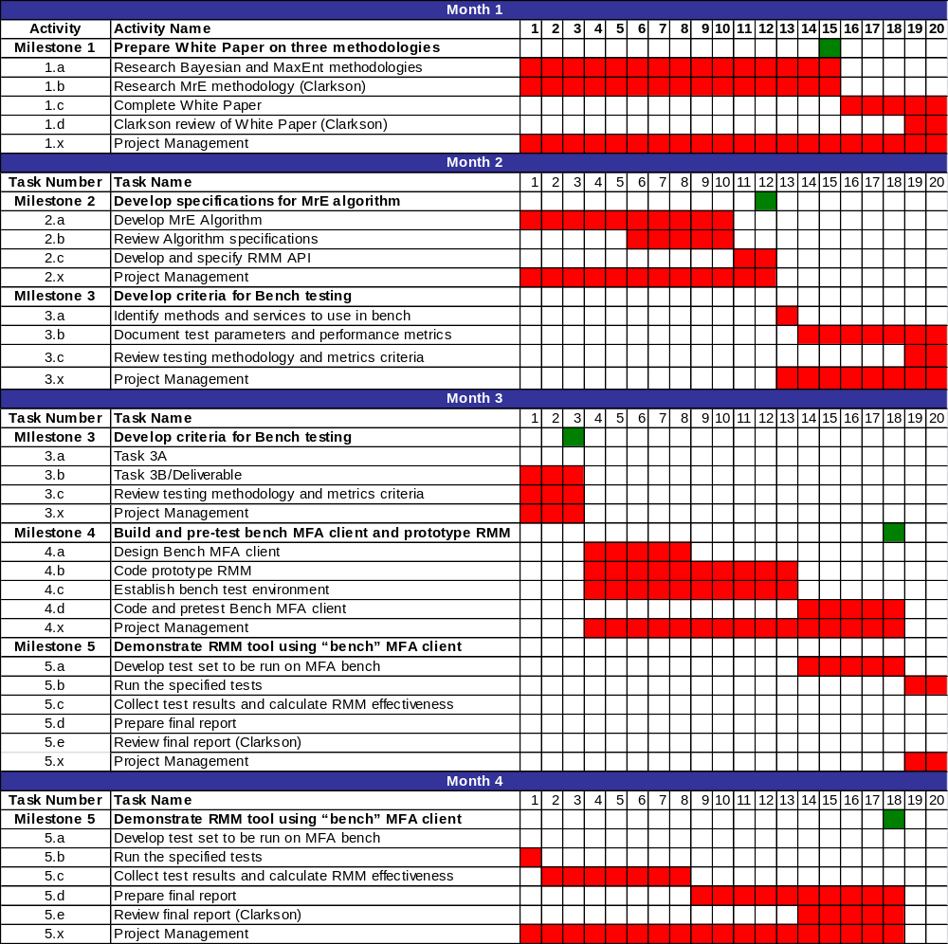

Cost
NOTE: The tables in this section are generated in Excel (see DARPA_Schedule_Costs.xlsx) and pasted as a Windows Metafile.

Table 2. Total Project Cost

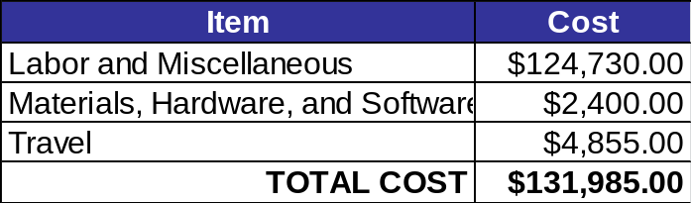

Labor and Miscellaneous Expenses

Table 3. Break-out of Labor Costs by Milestones and Tasks

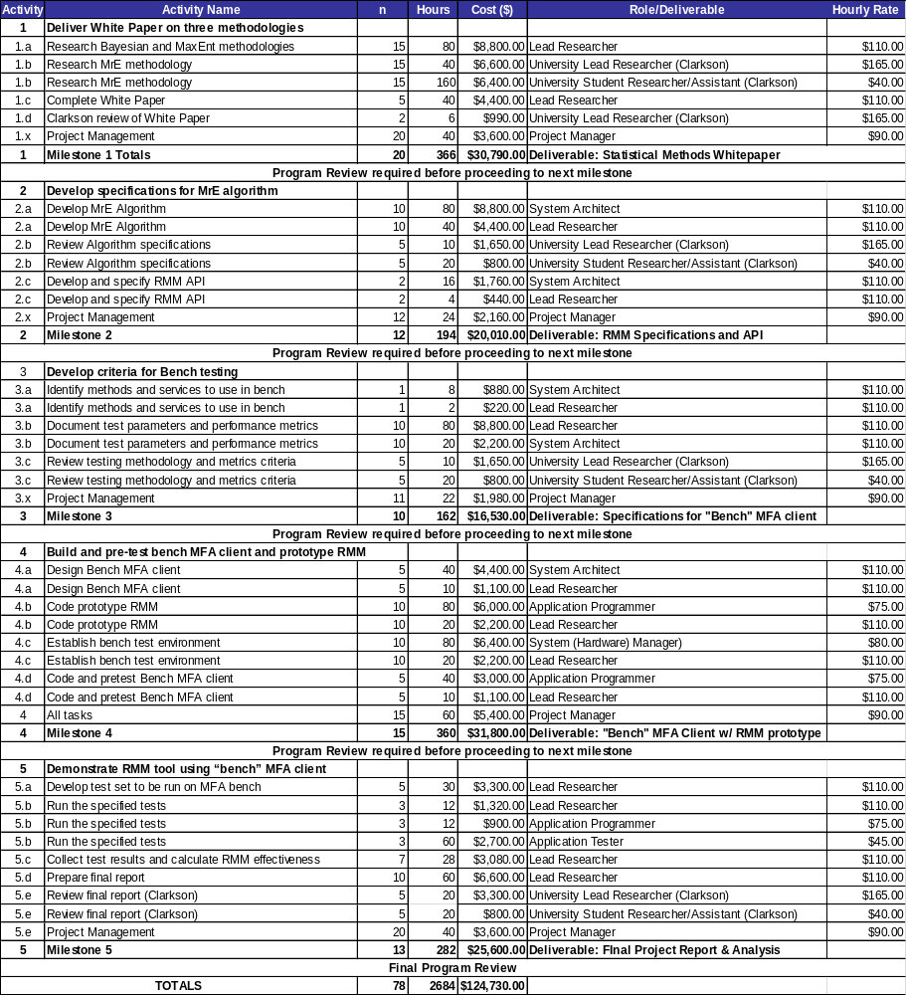

Materials, Hardware and Software Cost

Table 4. Materials, Hardware, and Software Costs

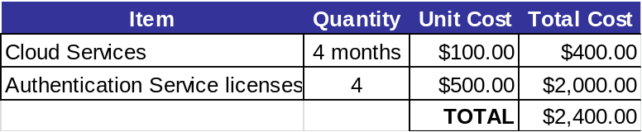
Travel

Table 5. Travel Costs

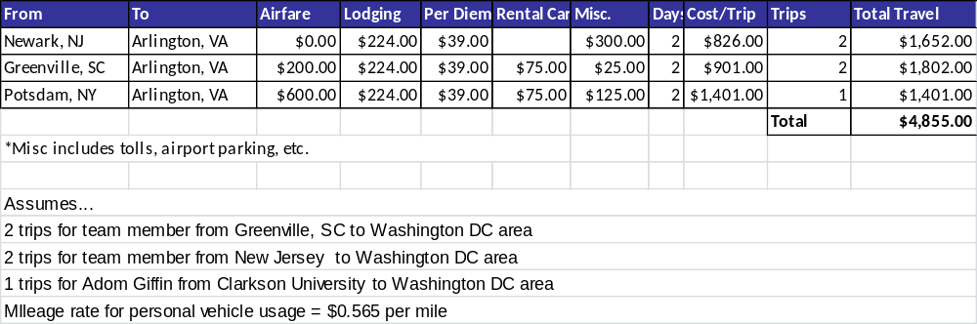

Appendix A

Team Member Identification
Proposer
Name:  ProvenSecure Solutions, LLC | Non-US Organization: ◻ Yes ☑ No  Non-US Individual: ◻ Yes ☑ No  FFRDC: ◻ Yes ☑ No  Government Entity: ◻ Yes ☑ No

Government or FFRDC Team Member
NONE

Organizational Conflict of Interest Affirmations and Disclosure
NONE

Intellectual Property
The proposal will make use of proprietary and/or commercially licensed services and/or software serving as representative authentication method. ProvenSecure will, where necessary, enter into temporary license arrangements with the owners of these services or software for a time sufficient to complete the research. ProvenSecure Solutions, LLC cannot make any deliveries or claims regarding GPR with respect to these components. Should the government desire to implement a production solution with these services or software, it will need to negotiate licenses independently with the owners of those services or software.
ProvenSecure Solutions, LLC will deliver the following:
- A white paper describing the effectiveness of Maximum Relative Entity analysis relative to Bayesian or Maximum Entity approaches as applied to assessing certainty of identification.
- Description of an algorithm describing the behavior of a Risk Mitigation Metric determination module.
- Specification of an API for a proposed Risk Mitigation Metric determination module.
- Specifications and source code for a prototype RMM module that will implement the above algorithm and API
- Specifications and source code for a “bench test” multi-factor authentication client that calls various (as yet undetermined) authentication verification services, as well as the RMM module to calculate certainty of identification
- A final report including test results and the analysis of same.
For all of these materials, ProvenSecure Solutions, LLC and/or its associates involved in this effort will grant Government Purposes Rights while retaining all other intellectual property rights to capabilities, future enhancements, and commercialization of the methodologies and software components.

Human Use
NONE

Mission-Oriented Risk and Design Analysis (MORDA), Don Buckshaw. MORS IA Special Session, 2007 http://www.mors.org/UserFiles/file/meetings/07ti/buckshaw.pdf
Handbook of Multibiometrics (Vol 6 of International Series on Biometrics) Arun A. Ross , Karthik Nandakumar , Anil K. Jain, Springer; 2011
From physics to economics: An econometric example using maximum relative entropy, Physica A: Statistical Mechanics and its Applications (Vol. 388, Issue 8) Adom Giffin, Elsevier, 15-Apr-2009

